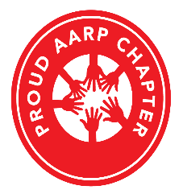
AARP Chapters Are Separately Incorporated Affiliates of AARP

AARP Suitland Maryland Chapter #939

2024 Scholarship Packet

Moto – “To Serve, Not To Be Served”

