

What is Breast Cancer Awareness Month and how it started.

The event began in 1985 as a week-long awareness campaign by the American Cancer Society, in partnership with Imperial Chemical Industries, a British company that made tamoxifen. The campaign eventually grew into a month-long event.

October marks 40 years since the launch of Breast Cancer Awareness Month, an initiative that has grown into one of the most recognized public health campaigns in the world. What started as a weeklong awareness effort has evolved into a global movement that turned the color pink, once merely symbolic, into a rallying point for millions of women, survivors, and advocates worldwide.

Saving Lives Through Awareness and Science
Four decades later, the results are undeniable. According to the American Cancer Society, more than 517,000 lives in the United States have been saved thanks to early detection, improved treatments, and public awareness.

By 1990, President George H. W. Bush officially proclaimed October as Breast Cancer Awareness Month, cementing its national importance. Two years later, the pink ribbon debuted through a partnership between SELF magazine and Estée Lauder executive Evelyn Lauder, a breast cancer survivor herself.

Breast Cancer Awareness Month, is held in October every year, and aims to promote screening and prevention of the disease, which affects one in eight women in the United States every year and 2.3 million women worldwide. Known best for its pink theme color, the month features a number of campaigns and programs — conducted by groups ranging from breast cancer advocacy organizations to local community organizations to major retailers — aimed at: supporting people diagnosed with breast cancer, including metastatic breast cancer educating people about breast cancer risk factors stressing the importance of regular screening, starting at age 40 or an age that’s appropriate for your personal breast cancer risk fundraising for breast cancer research.

Breast cancer is the most commonly diagnosed cancer among American women. Black women are most likely to die from breast cancer than women of any other racial or ethnic group. Experts believe that it’s partially because about 1 in 5 Black women is diagnosed with triple-negative breast cancer, more than any other racial or ethnic group. About 85% of breast cancers occur in women who have no family history of breast cancer. These occur due to genetic mutations that happen as a result of the aging process and life in general, rather than inherited.
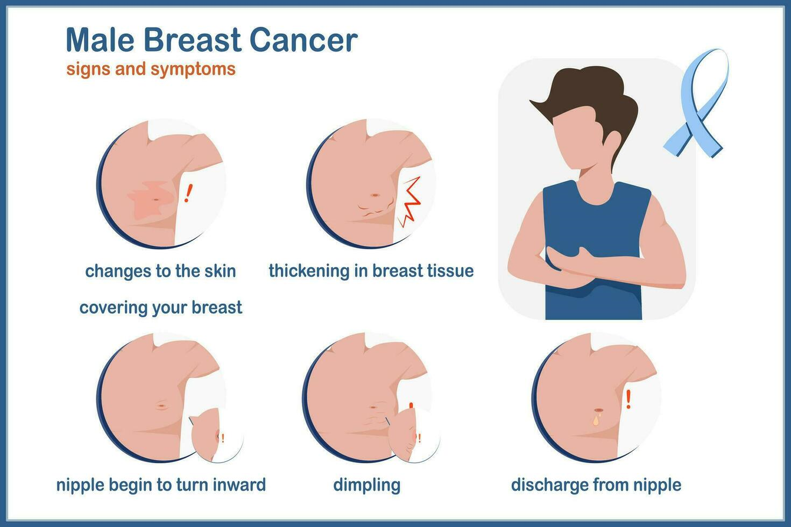

Men’s Breast Cancer Awareness Week - Although breast cancer is much more common in women, breast cancer affects men, too. In 2021, U.S. President Joe Biden designated October 17 to October 23 Men’s Breast Cancer Awareness Week. About 2,710 American men this year are expected to be diagnosed with breast cancer, and about 530 are expected to die from the disease. But lack of awareness and stigma can be barriers to detection and care. Some men, trans men, and non-binary people choose to call their cancer chest cancer.

BREAST CANCER: How does it start...
Breast cancer starts in the cells of the breast as a group of cancer cells that can then invade surrounding tissues or spread (metastasize) to other areas of the body. All people are born with some breast cells and tissue, including men. Advances in early detection and treatment methods have significantly increased breast cancer survival rates in recent years, and there are currently over 3.8 million breast cancer survivors in the United States.
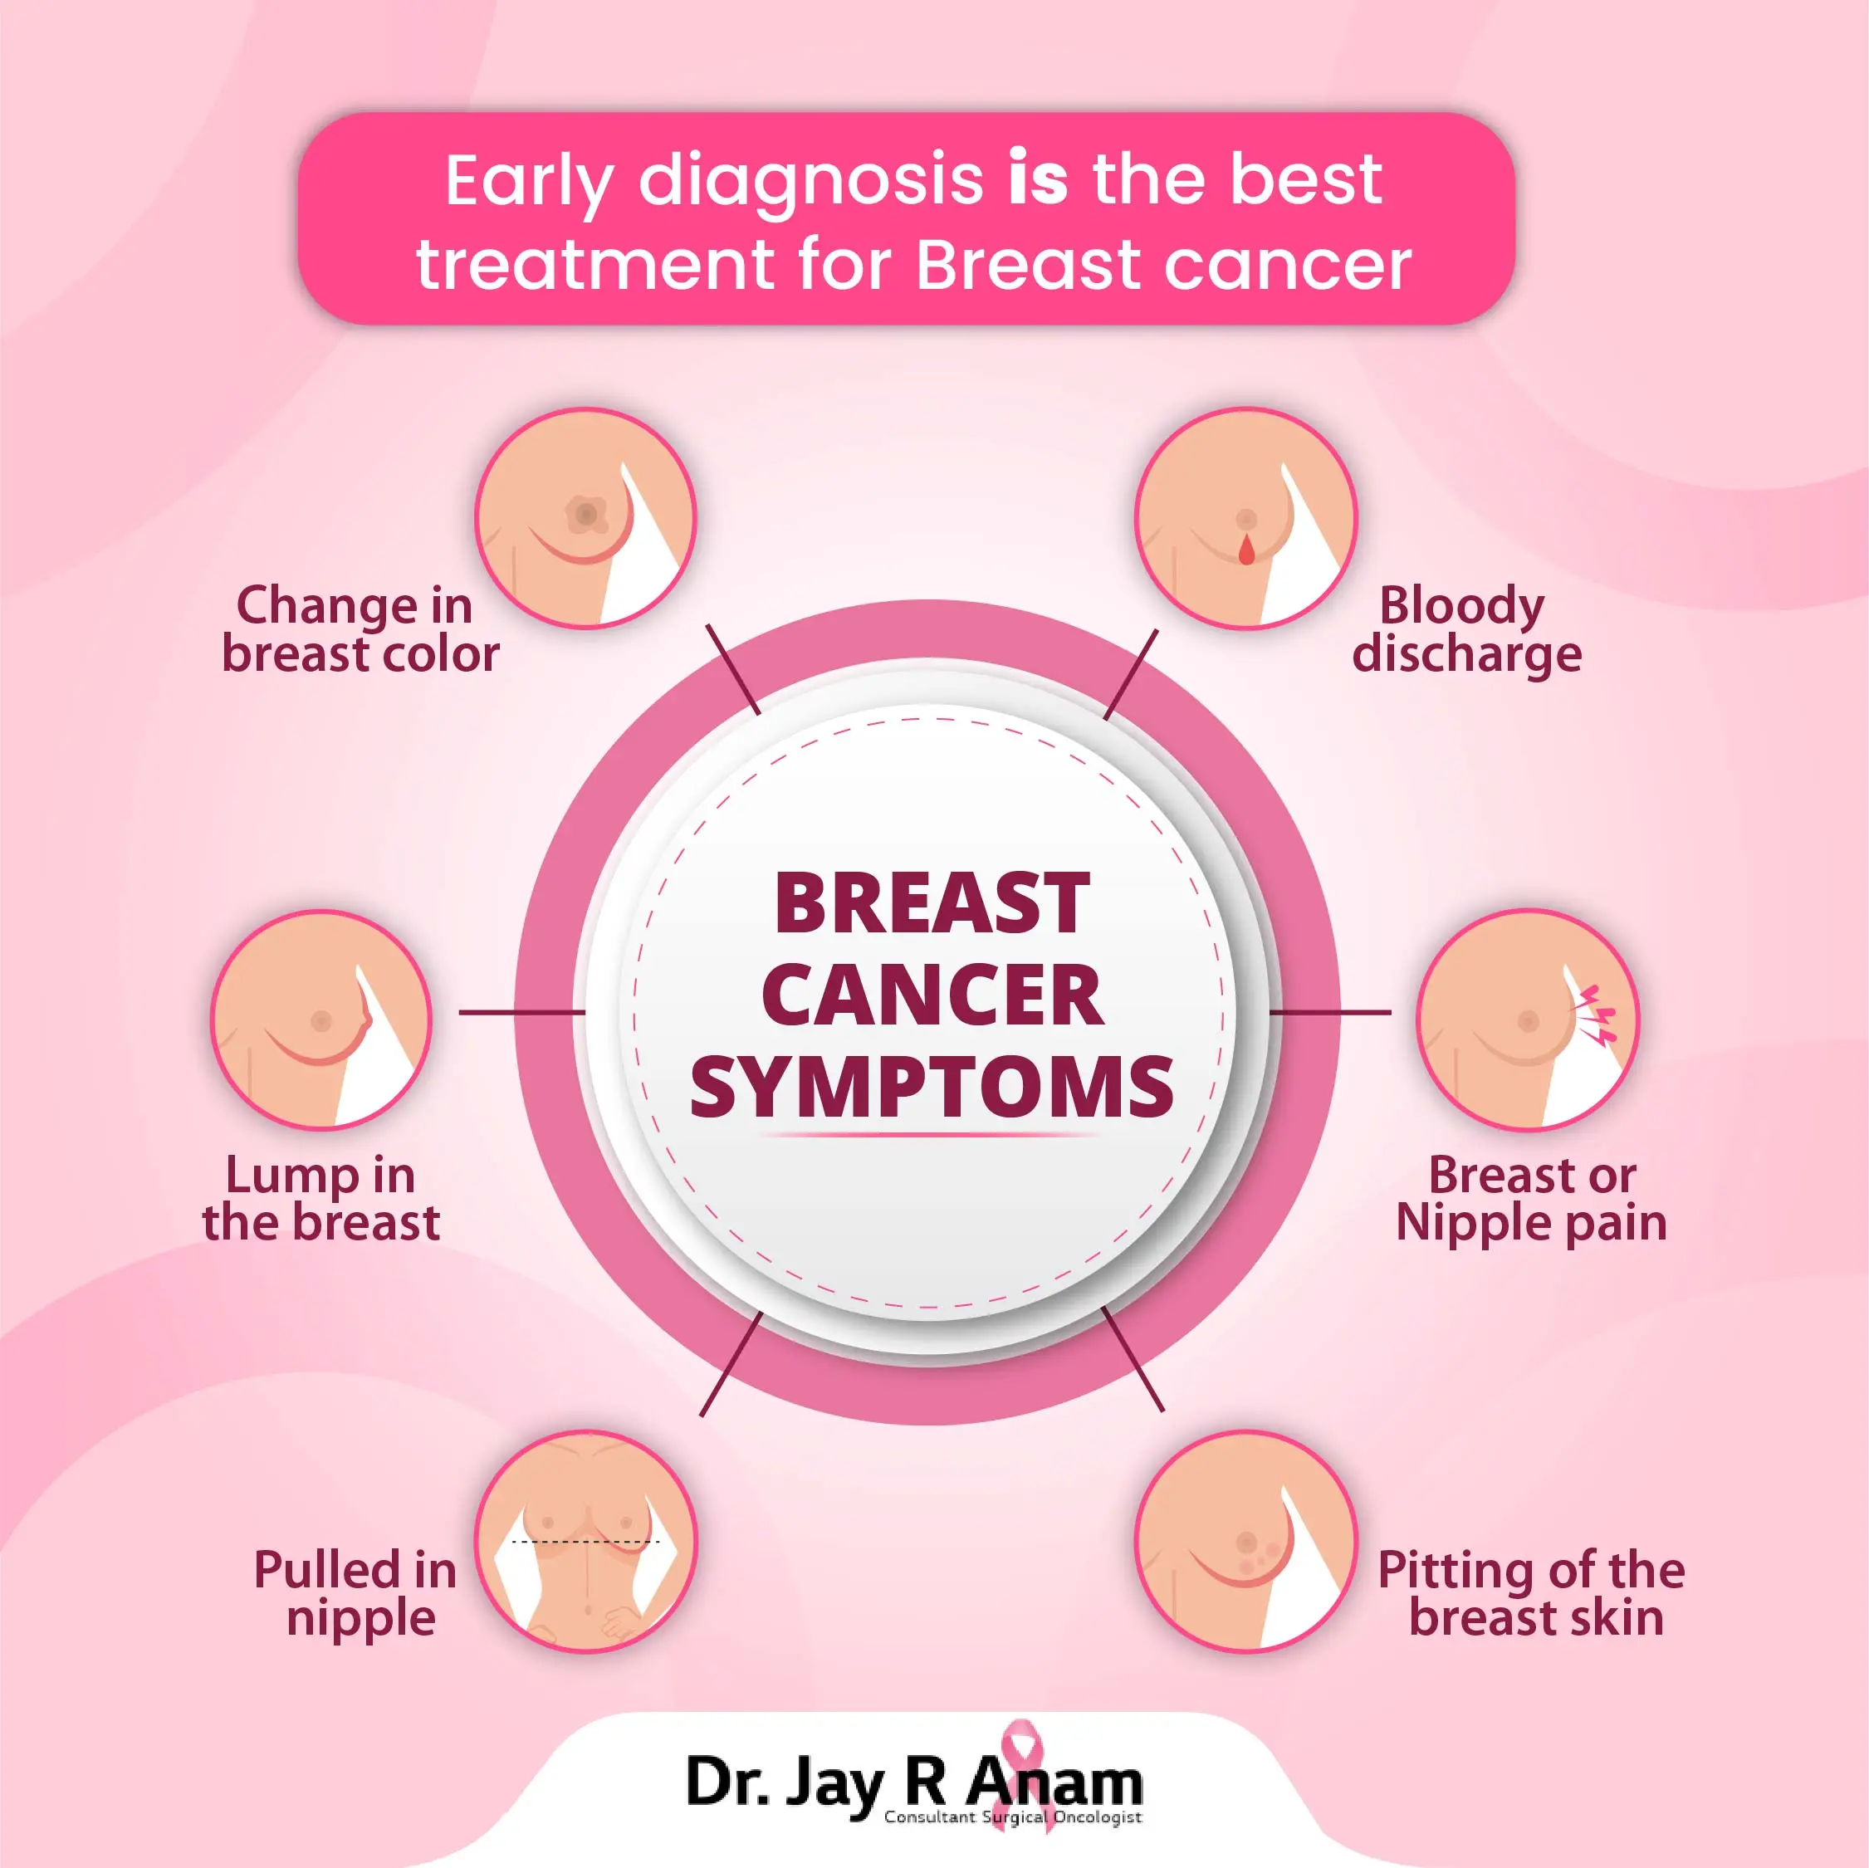

- Gender: Breast cancer occurs nearly 100 times more often in women than in men.
- Age: Two out of three women with invasive cancer are diagnosed after age 55.

- Family History and Genetic Factors: If your mother, sister, father, or child has been diagnosed with breast or ovarian cancer, you have a higher risk of being diagnosed with breast cancer in the future. Your risk increases if your relative was diagnosed before the age of 50.

- Personal Health History: If you have been diagnosed with breast cancer in one breast, you have an increased risk of being diagnosed with breast cancer in the other breast in the future.

- Menstrual and Reproductive History: Early menstruation (before age 12), late menopause (after age 55), having your first child at an older age, or never having given birth can increase your risk for breast cancer.

Environmental and lifestyle risk factors that can be changed may include:

- Lack of Physical Activity: A sedentary lifestyle with little physical activity can increase your risk for breast cancer. Moving your body or exercising for even 20 minutes a day can help lower this risk factor.

- Poor Diet: A diet high in saturated fat and lacking fruits and vegetables can increase your risk for breast cancer. Eating 3.5 to 5 cups of fruits and vegetables a day can help lower this risk factor.

- Being Overweight or Obese: Being overweight or obese can increase your risk for breast cancer. This risk increases if you have already gone through menopause.

- Drinking Alcohol: Frequent consumption of alcohol can increase your risk for breast cancer. The more alcohol you consume, the greater the risk.

- Radiation to the Chest: Having radiation therapy to the chest before the age of 30 can increase your risk for breast cancer. While radiation is often an unavoidable therapy for certain illnesses, it is still considered an environmental or lifestyle risk factor because it is not an inherited trait that someone is born with.

- Combined Hormone Replacement Therapy (HRT): Taking combined hormone replacement therapy, as prescribed for menopause, can increase your risk for breast cancer and increases the risk that the cancer will be detected at a more advanced stage.

Breast cancer screening and early detection play an important role in your health. Screening tests can help detect breast cancer at an early stage when the chances of survival are highest. Whether you’re ready to get your first screening mammogram or want to know more about follow-up tests after an abnormal finding, learning about breast cancer screening tests and the importance of early breast cancer detection can help you take charge of your health.

Why Breast Cancers Can Present Differently Later in Life

It’s important to point this out: While there’s a lot of attention on breast cancer in younger women, the disease is still more common in older women. The median age for a breast cancer diagnosis is 62, and only a very small number of women who are diagnosed with the disease are younger than 45, according to the American Cancer Society (ACS). “Breast cancer is predominantly a disease of aging,”
But many women mistakenly think that their risk of developing breast cancer goes down over time, says– James. “Therefore, they may be more likely not to have routine mammograms or report a new breast lump to their doctor. By delaying reporting concerning symptoms, their breast cancer may be diagnosed at a later stage and they may have a worse outcome.”

