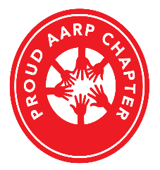
AARP Chapters Are Separately Incorporated Affiliates of AARP

AARP Suitland Maryland Chapter #939

2026 Scholarship Packet

Motto – “To Serve, Not To Be Served”

