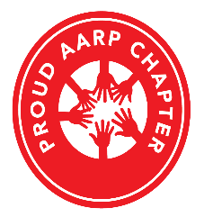
AARP Suitland, Maryland Chapter #939
Scholarship Application Essay Honor Pledge

- By signing below, the applicant agrees not to use Artificial Intelligence (AI) tools (such as ChatGPT, Google Bard, or Microsoft Bing Chat) which could complete the required essay with only minimal input from the applicant; nor use a commercial entity to purchase an essay.
- The applicant may use standard, non-AI enhanced search tools like: Google, Yahoo!, Bing, Lycos, AOL Search, Ask.com, or DuckDuckGo.
- The applicant further agrees to submit an electronic version of their essay to the Scholarship Committee in a Word, or Word-compatible format, and to accept the decision of the Scholarship Committee in regards to this Scholarship application.
- This application, and the submitted electronic version of the essay, become the property of AARP Suitland, Maryland Chapter #939, and will not be returned to the applicant.

________________________________
Scholarship Applicant’s Name (Printed)

________________________________
Scholarship Applicant’s Signature

